Cie 3 notes

* Semiconductors allow a controlled flow of electrons, forming the core of electronic devices.
* Before transistors (invented in 1948), vacuum tubes (valves) like vacuum diodes were used.
* Adv include:
  + Bulky, high power consumption, operated at ~100 V.
  + Low reliability and short lifespan.
* In the 1930s, it was discovered that solid-state semiconductors could control charge carriers.
* Semiconductors work without needing vacuum or heating and respond to light, heat, or small voltage changes.
* Advantages:
  + Compact size, low power consumption, low voltage operation, high reliability, and long life.
* Applications
  + Photovoltaics, Photodetectors, LEDs, Batteries, SC
* Important for sustainable energy solutions (e.g., generation and storage).

Classification

* Elemental semiconductors (Si, Ge).
* Compound semiconductors
  + Inorganic: CdS, GaAs, CdSe
  + Organic: fullurene, anthracene
  + Organic polymers: polypyrrole, polyaniline

Classification of Inorganic Semiconductors

* Intrinsic Semiconductors
* Extrinsic Semiconductors

**Intrinsic Semiconductor**

* Definition: Pure semiconductors with no impurities in the crystal.
* Common examples: Silicon (Si) and Germanium (Ge), which have a diamond-like crystal structure.
* Each Si/Ge atom has 4 valence electrons and shares them with 4 nearest neighbours, forming covalent bonds.

Properties:

* At T = 0 K: behaves like an insulator.
* At T > 0 K: thermal energy excites some electrons from valence band (Ev) to conduction band (Ec).
* This creates electron hole pairs.
* Number of free electrons (ne) = Number of holes (nh).
* Denoted as: ne = nh = ni (where ni is intrinsic carrier concentration).
* A diagram of a diagram of a diagram

  AI-generated content may be incorrect.

**Extrinsic Semiconductors**

* Definition: Doping of a pure (intrinsic) semiconductor (having low conductivity at room temp), with small amounts of impurities (dopants) to increase its electrical conductivity.
* The process of adding these dopants is called doping.
* Depending on the type of dopant:
  + If doped with pentavalent atoms (valency 5), it becomes an n-type semiconductor (extra electrons are majority carriers). e.g., As, Sb, P
  + If doped with trivalent atoms (valency 3), it becomes a p-type semiconductor (holes are majority carriers). e.g., In, B, Al

n-type Semiconductor

* How it works: Doped with pentavalent atoms (e.g., As).
* 4 electrons bond with silicon; 5th electron remains free.
* This extra electron becomes a charge carrier.
* Energy required to free this electron is very low (e.g., 0.01 eV for Ge, 0.05 eV for Si).
* These atoms are called donor impurities.

Characteristics:

* Electrons are majority carriers.
* ne (electron concentration) >> nh (hole concentration)
* Conduction is due to free electrons from dopants and a few from intrinsic excitation.
* A diagram of a molecule

  AI-generated content may be incorrect.

p-type Semiconductor

* How it works: Doped with trivalent atoms (e.g., B).
* Can bond with only 3 neighboring Si atoms.
* Leaves a hole (vacancy) where the 4th bond should be.
* Electrons from neighboring atoms may jump to fill the hole, creating mobile holes.

Characteristics:

* These dopants are called acceptor impurities.
* Holes are majority carriers, electrons are minority carriers.
* A diagram of a complex structure

  AI-generated content may be incorrect.

**Production of Electronic Grade Silicon (EGS)**

* Purpose: To produce high purity, single crystal silicon from bulk polycrystalline material for semiconductor devices.
* Method: solidifying silicon from its molten state. (Melt growth)

Crystal Growth Techniques

* Czochralski Method
* Float Zone Method

**Czochralski Method**

* Overview: A technique to grow single crystal silicon ingots (boules).
* These boules are sliced into thin circular wafers and then diced into little Si chips from which large scale integrated circuits are made.

Requirements:

* Furnace:
  + Includes fused silica crucible (SiO2), graphite susceptor, heating mechanism (resistance or RF), power supply and rotation system.
* Crystal Pulling Mechanism:
  + Includes seed holder, counterclockwise rotation
* Ambient Control:
  + Oxygen exclusion using Argon gas. Graphite parts can react with O2, forming CO2 which must be avoided.
* Control System:
  + Microprocessor based. Controls temperature, crystal diameter, pull rate, rotation speed

Working Principle:

* Melting: Polycrystalline silicon (the feed material) is melted at 1410°C in a crucible by resistance or radio frequency heater.
* Seeding: A seed crystal is dipped into the saturated molten silicon.
* Crystallization: Seed rotates counterclockwise, and the crucible rotates clockwise.
* Crystal grows as the seed is slowly pulled upward.
* Shape Control: Achieved by adjusting heating power, pull rate and rotation speed
* Diagram of a diagram of a process

  AI-generated content may be incorrect.

Final Product:

* Crystals up to 300 mm diameter, 300 kg weight
* Most imp technical application is growth of dislocation free silicon which is crucial in high performance electronics.

**Float Zone (FZ) Method**

Why FZ Over Cz?

* Cz wafers contain oxygen impurities due to contact with the SiO2 crucible, reducing minority carrier lifetime and inturn reducing efficiency of solar cells.
* Oxygen and its complexes may become active in higher temp making wafers sensitive to high temperature processing.
* FZ wafers are preferred in high efficiency or lab grade solar cells where purity is critical.

Working:

* It is a crucible free process i.e. no container touches the silicon.
* Surface tension maintains the molten silicon zone to be kept between the two vertical solid rods.
* A seed crystal is dipped into one end of the melt.
* The molten zone is moved along the feed rod.
* At the other end, crystal growth occurs as the molten silicon solidifies.

Advantages

* Avoids contamination from crucible materials.
* High purity crystals.
* Minimal crystal defects due to lack of container interaction.
* A diagram of a structure

  AI-generated content may be incorrect.

Disadvantage of FZ

* Size limitation: Max wafer diameter ≈ 200 mm (compared to up to 300 mm in Cz).
* Surface tension limits the zone width.
* This restricts its use to specialized applications, not mass production.

**GaAs**

General Overview

* GaAs (Gallium Arsenide) is a III-V compound semiconductor.
* Widely used in optoelectronics (LEDs, laser diodes) and microelectronics (high frequency ICs).
* Has FCC cubic structure, specifically zinc blende.

Electrical Properties

* Poor intrinsic conductivity makes it semi insulating in pure form.
* Doping with p-type or n-type impurities allows conductivity for device applications.
* High mobility and saturated drift velocity making it better than silicon for high freq applications.
* A graph of a graph of a number of mobility carriers

  AI-generated content may be incorrect.
* GaAs velocity peaks then drops (due to intervalley scattering), while Si saturates more gradually.

Optical Properties

* It is a direct bandgap semiconductor (1.42 eV)
* Direct bandgap means that the min of the CB is directly over the max of the VB.
* Transitions across the VB n CB require only a change in energy and no change in momentum
* This leads to efficient photon emission making it ideal for LEDs and laser diodes.
* A diagram of a graph

  AI-generated content may be incorrect.
* Only GaAs and InP are suitable for efficient light emission.

Semi-Insulating (SI) GaAs

* Used as substrates for Integrated circuits due to high resistivity and electrical isolation.
* Formed by either intentional doping with transition metal impurities during growth from melt or by relying on the formation of native defects during crystal growth.
* SI GaAs is mostly used as substrate for devices made by ion implantation method since it reduces parasitic cap0061citances.
* Key features include high resistivity, high mobility, thermal stability and low crystalline defects.

Applications of GaAs

* High freq app
  + Ideal for GPS, WLAN, and laser diodes.
  + Works well at high speeds and high temperatures.
* Transistors and Computer:
  + Used in transistors and logic circuits.
  + Faster electron transport than in silicon giving better performance.
* Defence and Aerospace
  + Used in radars, sensors, and secure comms.
  + Radiation resistance making it suitable for space applications.

**Silicon Germanium (Si₁₋ₓGeₓ) Summary**

Introduction

* Si(1-x)Ge(x) alloys have been researched since the 1950s, with practical applications rising in the past 30 years.
* Used initially in bipolar technologies, now common in MOS (metal oxide semiconductor) technologies.
* Silicon and germanium are completely miscible over the full range of x (0 to 1).
* The structure is diamond like cubic (same as silicon).

Thermoelectric Properties

* Thermoelectric effect: In presence of temperature gradient generates electric voltage and visa versa.
* Depends on the thermoelectric material figure of merit (zT)
* A mathematical equation with black text

  AI-generated content may be incorrect.
* S: Seebeck coefficient, σ: Electrical conductivity, κ: Thermal conductivity, T: Temperature
* For high efficiency, high S and σ, low κ are preferred.

Performance Highlights:

* Operates up to 1050°C without degradation.
* Doping (e.g., phosphorus (n-type), boron (p-type)) adjusts carrier concentration.
* Used in Voyager missions for over 40 years in space power systems (RTGs).
* Strategies like using 0D (clusters), 1D (nanotubes), 2D (layers) improve thermoelectric performance by reducing dimensionality.

Band Gap

* SiGe is an indirect band gap semiconductor.
* Has a narrower band gap than pure silicon.
* The band gap is tunable by changing germanium content (x).

Doping & Fabrication

* SiGe can be doped p- or n-type when amorphous.
* Doping is difficult in crystalline SiGe due to high crystallization temperatures.
* Challenges in growing high quality doped films for mass production.

Applications

* Space Industry: RTG generators in deep space missions (e.g., Voyager).
* Automotive: Ideal for rectifiers in high temp environments.
* Electronics & Telecommunication:
  + Used in Heterojunction Bipolar Transistors (HBTs).
  + Enables bandgap engineering within silicon systems.
* Solar Industry:
  + 4× faster carrier mobility in comparison to silicon.
  + Reduces energy loss, allows smaller, faster solar cells.
* Optical Interconnects:
  + High speed detection, low cost, suitable for IC interconnects in optical devices.

**Indium Phosphide (InP)**

* Material Class: Group IIIA phosphide nanocrystalline semiconductors.
* Key features include large direct band gap, strong covalent bonding and less ionic character.
* Used in high speed digital, microwave, and optoelectronic devices.

Optoelectronic Properties

* Photoluminescence: It is an optical phenomenon that semiconductors give light emissions by absorbing photons with energy higher than its energy band gap.
* Quantum Dots (QDs):
  + Size tunable optical band gap covering visible spectrum.
  + Non-toxic alternative to Cd- and Pb-based QDs.
* Band Gap: 1.35 eV, suitable for both visible and near infrared light.
* Heterojunction Compatibility: InP works well with ZnS, ZnSe, and Graphene for various device applications like displays, solar cells, and photodetectors.

Applications of InP

* InP Nanowire-Based Solar Cells:
  + Uses core shell pn junction InP NWs.
  + Achieved solar efficiency of 13.8%.
* InP Polymer Hybrid Photodiodes:
  + Enhances carrier collection.
  + Cost effective ITO substrates used.
  + Suitable for optoelectronic sensing.
* InP Nanowires as LEDs:
  + pn junctions emit polarized light under forward bias.
* Field-Effect Transistors (FETs):
  + ZnS sensitized InP NWs enable good p-type transistor behavior.
* Bioimaging:
  + Non-toxic alternative to CdSe QDs.
  + Folic acid–capped InP QDs target tumor cells (e.g., human oral carcinoma).

**Organic Semiconductors: Overview**

* Definition: Materials that combine electrical adv of semiconducting materials with the chemical/mechanical benefits of organic compounds (like plastics).
* Advantages:
  + Absorb and emit light.
  + Conduct electricity.
  + Mechanically flexible, lightweight, and soluble.
  + Easily modified chemically for tailored properties.
* Composition:
  + Primarily made of carbon and hydrogen atoms.
  + May include heteroatoms like sulfur, oxygen, nitrogen.
  + Exhibit properties typical of inorganic semiconductors.
* Conductivity: Originates from:
  + Charge injection at electrodes.
  + Doping (intentional/unintentional).
  + Dissociation of photogenerated electron hole pairs.

Origin of Semiconducting Property in Organic Molecules

* Molecular Structure:
  + Composed of conjugated systems (alternating single and double bonds).
  + π orbital delocalization allows electron mobility within molecules.
* Intermolecular Bonding:
  + Molecules are held together via weak van der Waals interactions.
    - Leads to localized electrons (except in π orbitals) and narrow electronic bandwidths.
* π - π Overlap:
  + Key for electron delocalization.
  + Greater π - π overlap → better charge transport.
  + HOMO-LUMO energy gap analogous to band gap in inorganic semiconductors.

Types of Organic Semiconductors

* Amorphous Molecular Films:
  + Formed by evaporation or spin coating.
  + Used in LEDs, xerography (MDP films).
* Molecular Crystals:
  + Comprise a regular lattice.
  + Molecules like naphthalene, anthracene, etc.
  + High charge mobility makes it suitable for transistors.
* Polymer Films:
  + Long chains of repeating molecular units.
  + Processed from solution (spin-coating, ink jet, reel to reel coating).
  + Blends enhance stability and reduce crystallization susceptibility.

**Pentacene**

* Structure: A linear acene molecule made of five fused benzene rings.
* Application: Ideal for highly ordered organic thin-film transistors (OTFTs).
* Crystal Structure: Forms molecular crystals with a herringbone packing.
* Electron Transport: Delocalized π orbitals facilitate efficient charge movement via π–π stacking.
* Lattice: Adopts a triclinic lattice structure in bulk.
* 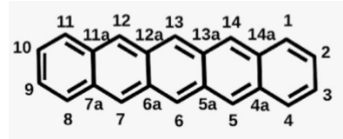

Synthesis of Pentacene

Step 1:

* Reactant: Pentacene-6,13-dione.
* Solid NaBH4 was added to the round bottom flask containing suspension of THF at 0 °C.
* Then the reaction mixture was purged with N2 and water was added.
* The mixture was heated to 50–60 °C until it becomes homogeneous.
* After 2 hrs o f heating, THF was evaporated at reduced pressure, water was added and the reaction mixture was filtered.
* The solid were washed with water. After drying, a white solid was recovered.
* Product: 6,13-dihydroxy-6,13-dihydropentacene (85% yield).

Step 2:

* Reactant: Dihydropentacene.
* The obtained product was stirred with SnCl2 (1:2 mole ratio) in acetone.
* The resulting crude pentacene was isolated by centrifuge and washed with both methanol and THF.
* Purification of sublimation resulted in pure pentacene (yield ~60%).

Fabrication of Pentacene Thin Films

* It is sensitive to air (moisture, oxygen) and low solubility makes it unstable with standard fabrication methods.
* Thus, pentacene should be deposited using evaporation techniques to fabricate thin films for electronic devices.
* It is an energy intensive process.
* To overcome this, substituents are introduced to the aromatic core, which increases the stability, solubility, and packing for better electrical properties. of the pentacene.

Thermal Evaporation Technique

* Organic molecular beam deposition (OMBD) one of the thermal deposition technique is used to produce high quality thin films of pentacene.
* Uses ultra high vacuum to evaporate material.
* Molecules are sublimated and deposited on a substrate which is placed parallel to the sublimed molecules.
* Advantages include high control over film thickness and order.
* Diagram of a vacuum chamber

  AI-generated content may be incorrect.

Spin Coating:

* Simple and widely used due to its capacity for mass production and cheaper costs.
* A solution is dropped on a spinning substrate which starts spinning with a certain acceleration rate and remains at const. speed for a period of time.
* Thin film is formed as solvent evaporates.
* A diagram of a structure

  AI-generated content may be incorrect.

App of pentacene

* Solar Cells
  + Used as an active layer in donor acceptor solar cells.
  + Pentacene was stacked with PTCDI and this layer is deposited onto PEDOT-PSS layer via thermal evaporation (3 × 10⁻⁷ Torr, 1 Å/s) to obtain 50 nm of pentacene.
  + 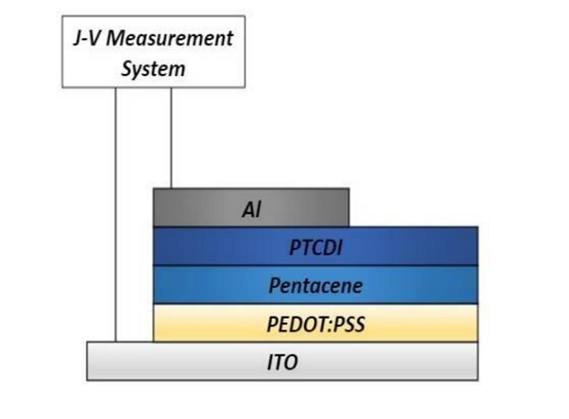
* Photodetector
  + Used in flexible photodetectors.
  + 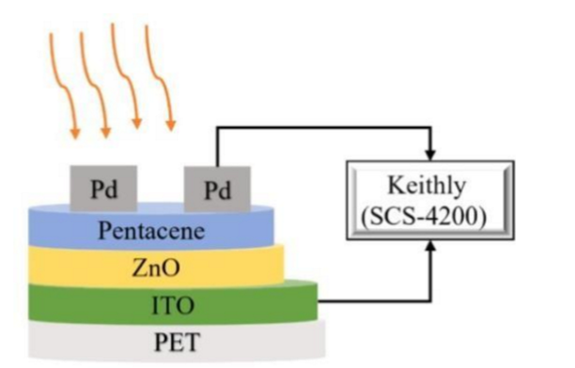
* Organic Thin Film Transistor (OTFT)
  + Common in organic field effect transistors (OFETs) due to high charge mobility.
  + A diagram of a structure

    AI-generated content may be incorrect.
* OLED (Organic Light Emitting Diode)
  + Used as a component to improve current efficiency in OLEDs.
  + A diagram of a diagram

    AI-generated content may be incorrect.

**Fullerene**

* Definition: Fullerenes are allotropes of carbon, forming hollow molecular structures either spherical (e.g., C₆₀, "buckyballs") or cylindrical (carbon nanotubes)
* Named acc to the number of carbon atoms in the structure.

C₆₀ Molecule (Buckminsterfullerene):

* 60 carbon atoms, diameter ≈ 7.09 Å
* Shape: Truncated icosahedron (soccer ball like)
* Each vertex has one carbon atom, and each carbon has 1 double bond and 2 single bonds
* Contains 12 pentagonal rings
* Can be viewed as a rolled up graphene sheet

Properties:

* Act as electron acceptors due to low energy and triply degenerate LUMO (easily accepts electrons)
* Exhibit low reorganization energy, leading to efficient charge separation, reduced recombination, and long lived charge separated states.
* High spherical symmetry supports good electron delocalization and stability.
* Fullerenes and derivatives act as n-type materials due to excellent electron affinity.

Synthesis of PCBM

* Two-Step Process:
* [2+1] Cycloaddition reaction of C₆₀ with diazoalkane to form fulleroid intermediate
* Isomerization converts the fulleroid into PCBM by thermal or photoisomerization
* A diagram of a molecule

  AI-generated content may be incorrect.

App of fulerenes

* Solar Cells
  + Efficient electron acceptors making them promising candidates for construction of solar panels.
  + A stack of colorful blocks

    AI-generated content may be incorrect.
* Organic Thin Film Transistors (OTFT)
  + Used as active semiconducting material.
  + Materials: Fullerene and pentacene often used due to high electron/hole mobility.
  + A diagram of a structure

    AI-generated content may be incorrect.
* Batteries and Supercapacitors
  + Electrochemical intercalation of lithium leads to C₆₀Li₁₂ formation.
  + Fullerene (C₆₀) and its derivatives used for anode materials in lithium ion batteries.
* Sensors
  + Due to high conductivity, charge transport, and separation abilities, fullerenes are ideal for strain sensors, gas sensors, photoelectrochemical sensors, electrochemical and optical sensors
* Biomedical Applications
  + Excellent electrochemical sensitivity of C₆₀.
  + Used in detection of biomolecules: dopamine, glucose, uric acid, etc.
* Superconductors
  + When alkali metals (e.g., potassium) are embedded in C₆₀, the compound becomes a superconductor. eg K₃C₆₀
  + It possesses high transition temperature, 3D superconductivity, good current density, ductility, and stability

**Conductive polymers**

* Traditionally, polymers were insulators, but a special class called Intrinsically Conducting Polymers (ICPs) or Organic Conductive Polymers can act as semiconductors or conductors.

Key Characteristics:

* They contain alternating single and double bonds (conjugated systems) or aromatic rings (e.g., phenylene, thiophene).
* First significant conducting polymer: Polyacetylene (polyethyne).
* Examples of Conductive Polymers include Polyacetylene, Polyaniline etc

Properties:

* High Melting/Softening Points due to restricted mobility from aromatic ring structures and absence of free rotation.
* Excellent Stability: chemically, thermally, and oxidatively stable due to low hydrogen content and aromatic nature.
* Processability: can be fabricated into highly ordered, crystalline thin films that conduct electricity when doped.

Mechanism of Conductivity:

* Conductive polymers rely on delocalized π electrons in conjugated systems.
* These create a band structure like semiconductors.
* Doping (p-type or n-type) introduces charge carriers by removing electron from VB by oxidation (p doping) or adding electrons to CB by reduction (n doping).
* Delocalization of electrons across the π system enhances conductivity.

**Polyaniline (originally called aniline black).**

* It is a mixed oxidation state polymer containing benzoid and quinoid units.
* It has characteristics of switching between conductive and insulating states depending on experimental conditions.
* PANI exists in three oxidation states, defined by the parameter 1−y:

| Form | Oxidation State (1 − y) | Description |
| --- | --- | --- |
| Leucoemeraldine (LE) | 0 | Fully reduced, all benzoid units |
| Emeraldine Base (EB) | 0.5 | Half oxidized, alternating benzoid and quinoid units; most stable and useful form, acts as a semiconductor |
| Pernigraniline (PE) | 1 | Fully oxidized, all quinoid units |

Preparation of (PANI)

* Synthesis Steps:
* Reactants: Aniline and APS (Ammonium Persulfate) in 1.0 M HCl.
* Process:
* Stirred vigorously at ~0 °C.
* Oxidative polymerization occurs forming a dark green PANI powder.
* Post-treatment:
* Filter and wash with 1.0 M HCl and distilled water until clear.
* Final wash with acetone, dry at 60 °C.

Applications of PANI

* Solar Cells:
  + Used in Dye Sensitized Solar Cells (DSSC).
  + Attractive due to low cost, easy synthesis, and conductivity.
* Electrochromic Glasses:
  + Smart glass changes color under electric current.
  + PANI reflects blue and is used to control light transmission (e.g., car windows).
* Electroluminescence Machines:
  + Used in devices that emit light upon electrical stimulation.
* Sensors:
  + Due to redox sensitivity, ideal for detecting gases, biomolecules, etc.

Magnetic Materials for data storing

Principle of Magnetic Recording:

* Data is written on a medium (disk/tape) that contains magnetic layers.
* Uses magnets with north and south poles to encode data.
* Magnetic field sensors detect the magnetic field which allows data reading.
* External magnetic fields change polarity which allows data writing.

Working Mechanism:

* Identical poles (N–N or S–S) create a magnetic field whose voltage detected by GMR sensor which represents “1”.
* Opposite poles (N–S) do not produce a field. Thus no voltage and represents “0”.

Materials Used:

* Elements: Iron (Fe), Nickel (Ni), Cobalt (Co).
* Alloys: Co–Pd, Pt–Fe nanoparticles.
* Thin films: Co–Ni–Pt, Co–Cr–Ta.
* Others: γ-Fe₂O₃, single-atom Ho on MgO, carbon coatings for durability.

Dielectric Materials for Storage Devices

* Role in Memory:
  + Dielectrics are poor conductors but get polarized when voltage is applied.
  + Used in volatile (DRAM) and non-volatile (RRAM) memories.
* RRAM (Resistive Random Access Memory) Working Principle:
  + Structure: Electrode/Dielectric/Electrode.
  + Based on resistance change (switching between high and low resistance).
  + The storage medium uses High Resistance State (HRS) and Low Resistance State (LRS) to represent 1 and 0 of binary code.
  + Flexible versions use cross array structures to maximize density to improve storage density.

Dielectric Materials Used

* 1. Inorganic Materials:
* Oxides: TiO₂, NiOₓ, ZnOₓ, AlOₓ, WOₓ, HfOₓ, MoOₓ
* Others: HfTiO₄, ZnSnOₓ, Si₃N₄, BN, amorphous Si
* 2. Organic Materials:
* Polymers: Lignin, polyimide (PI), PEGDMA, starch, NC
* Example: pV3D3, polyparaxylylene
* 3. Organic-Inorganic Composites:
* Combinations:
* PVP:GO, ultrathin HfOₓ
* HKUST-1 (MOF: Cu₃(BTC)₂)

Applications of Dielectric Materials:

* Resistive switching memory
* Thin-film transistors
* Film capacitors
* Dielectric actuators
* Capacitive sensors

Photochromic Materials:

* Definition: Substances that reversibly change color when exposed to light, especially UV light.
* They absorb light, undergo a reversible chemical change in structure and color, and return to the original state when the light source is removed.
* Available in glass, plastic, or powder form.

Important Compounds

* Diarylthene (DE), Dithienylethene (DT), Furylfulgide (FF): thermally stable and resistant to photochemical side reactions and used in optical information storage.
* Spirooxazines (SO) and Spiropyrans (SP): Used in optical switches, often embedded in sol-gel glasses.

Working Principle

* It is a reversible photochemical reaction that occurs when material is exposed to light.
* The photochromic material absorbs light energy and undergoes a reversible chemical reaction that changes its molecular structure and color.
* When the light source is removed, the material returns to its original state.
* UV light changes molecular structure.
* UV exposure triggers molecular shift, increasing light absorption and gives the lenses a darkened appearance.
* In absence of UV, molecules revert and become transparent again.
* Photochemical molecules are sensitive to both the presence and amount of UV light.

Photochromic Lenses: Structure & Mechanism

* Transparent indoors and darken when exposed to UV light from sun
* Provide benefits of both glasses and sunglasses in a single frame.
* Plastic Lenses: Have carbon based compounds within them that change structure in presence of UV light.
* Glass Lenses: Contain silver halide crystals (like silver chloride).
* UV light causes silver gains an electron (Ag⁺ → Ag⁰), darkening the lens.
* In absence of UV, a second compound (like copper chloride) reverses the reaction.
* 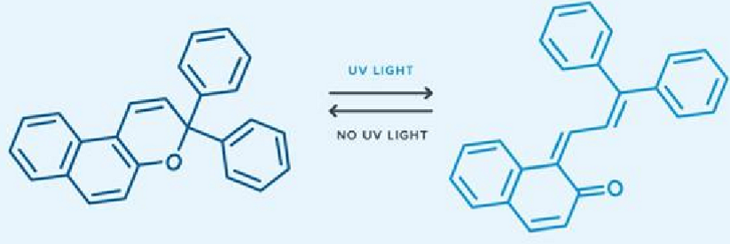
* UV light causes a bond to cleave (oxygen-carbon), altering the molecules shape and properties.

Advantages of Photochromic Lenses

* Dual purpose: Act as both prescription glasses and sunglasses.
* Provide full protection from UVA and UVB rays.

Disadvantages

* Unsafe for driving: Lenses may darken behind windshields.
* Some are not polarized, causing glare issues.

Applications of Photochromic Materials

* Photochromic units can be used to create molecules that can switch shape, func or interactions with light.
* Photochromic compounds can be used to store info in optical media by changing a reflectivity with light.
* Photochromic materials can be used to store solar energy by converting light into heat or electricity and releasing it when needed.
* Photochromic dyes can be used to make fabrics that change color with light

Thermochromic Materials:

* Definition: Thermochromic materials change color due to temperature changes.
* Common Applications: Kettles, Coffee cups, Temperature indicators

Types of Thermochromic Materials:

* 1. Liquid Crystals (LCs):
  + Organic compounds that reflect different colors at different temperatures.
  + Examples: Cholesteryl esters, ethers, benzoates, oleyl carbonates.
  + Applications: Thermometers, mood rings, thermal cards.
* 2. Leuco Dyes:
  + Organic molecules that switch between colored and colorless states when they interact with other chemicals at certain temps
  + Examples: Crystal violet lactone, malachite green lactone, phenolphthalein, fluoran.
  + Used in papers, polymers, inks, etc.
* 3. Inorganic Materials:
  + Change optical properties due to change in crystal structure or electronic configuration at certain temps.
  + Include metal oxides like: Titanium dioxide (TiO₂), Zinc oxide (ZnO)

Working Principle of Liquid Crystal Thermochromic Materials:

* These materials reflect light differently depending on temperature and molecular alignment.
* Operate based on selective reflection of certain wavelengths depending on temp and orientation of molecules.
* Exhibit a phase change from crystalline (chiral/twisted nematic phase) at low temp to isotropic (liquid) phase at high temp.
* Only nematic mesophase shows thermochromic properties which restricts the effective temperature range of material.
* 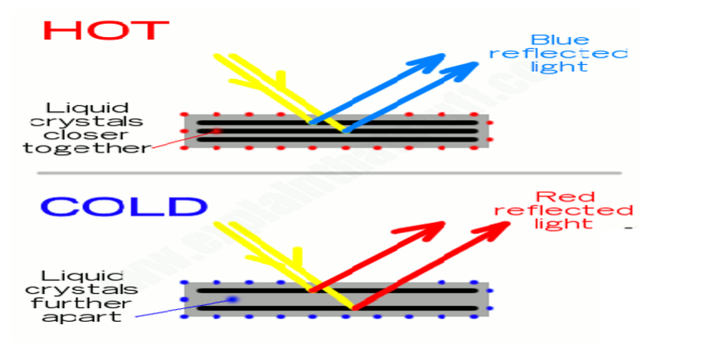
* Hot: Crystals are closer together, reflects blue light.
* Cold: Crystals spread out, reflects red light.

Applications of Thermochromic Materials:

* Temperature Indicators in Industry (chemical reactions, heat variation)
* Thermometers for rooms, refrigerators etc
* Indicator of level of propane in tanks, which change color depending on temp
* Heat transfer mapping devices which shows heat and convection patterns.
* Artistic and educational materials such as mood rings, thermal cards etc

Electrochromic Materials

* Definition: Electrochromic materials change color or opacity when an electric field is applied.
* Unlike photochromic (light sensitive) or thermochromic (temperature sensitive) materials, electrochromic materials respond to voltage/electric field.
* Applications: Used in smart windows, mirrors, sunglasses, and other devices that manage light and heat transmission.

Types of Electrochromic Materials

* Metal Oxides:
  + Inorganic compounds that undergo color changes by ion/electron exchange.
  + Example: Tungsten oxide (WO₃) changes from transparent to blue when voltage is applied.
* Conducting Polymers:
  + Organic compounds that change color by oxidation state changes.
  + Example: Polyaniline shifts from green to blue.
* Organic Dyes:
  + Undergo redox reactions to change molecular structure and hence color.
  + Example: Viologen changes from colorless to blue or red.

Working Principle

* It is based on reversible change in optical properties caused by redox reactions.
* When the material is placed on the surface of an electrode, an electric field can induce redox reactions and change the color or opacity of the material.
* The color change can be between a transparent state and a color state or between two colored states.
* The color change can be controlled by the mag of the applied voltage.

Device Structure: Electrochromic Device (ECD)

* Mechanism:
  + Electrons and charge balancing ions migrate into EC layer and thus optical absorption occurs.
  + Voltage induces redox reactions, changing color or transparency.
* 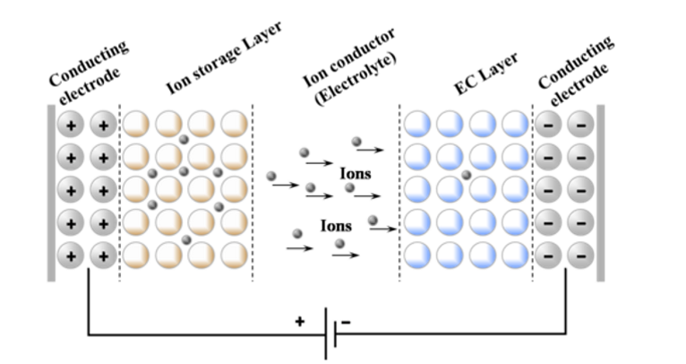
* Shows electron & ion movement between ion storage and EC layers, enclosed by electrodes.

Device Operation Modes:

* 1. Transmittance Mode:
  + Transparent conducting electrodes (TCE) on both sides.
  + Controls light intensity (used in smart windows).
* 2. Reflectance Mode:
  + One TCE replaced by reflective material (e.g., aluminum, silver).
  + Controls light reflection (used in rear-view mirrors).
* 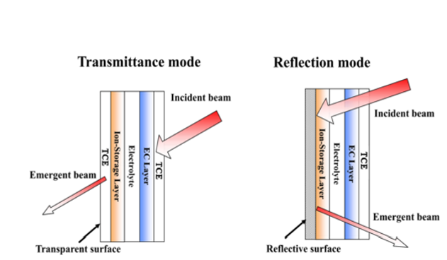

Applications:

* Auto dimming rearview mirrors
* Smart sunglasses or adaptive goggles
* Sensors, optical shutters/modulators

General Device Structure:

* Illustrates:
  + Movement of electrons (e⁻) and ions
  + Layers: Electrochromic layer, Ion storage, Electrolyte
  + Reversible reaction: MV²⁺ + e⁻ ⇌ MV⁺ (redox process)
* Diagram of electrochromic material with text

  AI-generated content may be incorrect.

Thin Film Deposition Techniques

* Definition: Thin films are layer of material ranging from a few nanometers to several micrometers thick, used in various technological applications.

Classification of Thin Films

* (a) Single crystals
* (b) Epitaxial
* (c) Polycrystalline
* (d) Amorphous

Properties of Thin Films

* High surface to volume ratio
* Geometrical control by substrate
* Compact structure
* Properties similar to single crystals

Uses of Thin Films

* Microelectronic and telecommunication devices
* Decorative and optical coatings
* Sensors and catalysts

Thin Film Deposition Methods

* Physical Vapour Deposition (PVD)
* Chemical Vapour Deposition (CVD)

Chemical Vapour Deposition (CVD)

* Formation of non-volatile solid thin films on substrates by chemical reactions of vapor phase precursors.
* Involves introduction, decomposition, and reaction of gases in a reactor chamber.

CVD Apparatus Components

* Gas delivery system: Supplies reactants
* Reactor chamber: Where deposition occurs
* Substrate loading: Holds/removes substrates
* Energy source: Provides required heat/energy
* Vacuum & exhaust systems: Removes excess and by-products
* Process control equipment: Monitors pressure, temperature, time

Steps in a CVD Process

* Transport of reactants by forced convection to the deposition region.
* Transport of reactants by diffusion from main gas stream through the boundary layer to wafer surface.
* Adsorption of reactants on wafer surface.
* Surface reactions including decomposition, migration, and incorporation
* Desorption of by products from the surface.
* Transport of byproducts by diffusion through boundary layer back to the main gas stream.
* Transport of byproducts by forced convection away from the deposition region.
* A diagram of a gas stream

  AI-generated content may be incorrect.

Advantages of CVD

* High growth rates
* Suitable for materials which are hard to evaporate
* Good reproducibility
* Can grow epitaxial films

Disadvantages

* High temperatures required
* Complex setup
* Use of toxic/corrosive gases

Applications

* Protective coatings (wear, corrosion, erosion, temperature)
* Semiconductors and integrated circuits
* Sensors and optoelectronic devices

Plasma Enhanced Chemical Vapor Deposition (PECVD)

* Definition: PECVD is a type of chemical vapor deposition that uses plasma to enhance chemical reactions at lower temperatures.
* It is used to deposit thin films from gas state (vapor) to solid state.
* It converts reactant gases into a plasma, allowing thin films to be deposited on substrates from vapor.

Key Features

* The plasma is created by applying Radio Frequency or DC energy between electrodes.
* Plasma activates gases, leading to surface reactions.
* Films form on substrates as gases decompose and react.

Advantages Over Conventional CVD

* Lower deposition temperatures (Room temp to ~350°C vs 600–800°C in CVD)
* Better step coverage on uneven surfaces (trenches, walls, etc.)
* Tighter control of film properties
* High deposition rates
* Reduced thermal stress on devices
* Enables high performance bonding and electrical properties

How PECVD Works

* The substrate is placed between two electrodes in a deposition chamber
* Substrate is heated to 250–350°C
* Gases like silane (SiH₄) and ammonia (NH₃), with argon or nitrogen, are introduced
* Electrical discharge ignites plasma (100–300 eV), forming a glowing sheath
* Energized electrons collide with gas molecules in plasma
* Reactive species are transported via gas flow to substrate
* Chemical reactions form a film on the substrate
* By-products are pumped away
* Gas flow rates and temperatures affect film thickness, hardness, refractive index
* Diagram of a vacuum supply system

  AI-generated content may be incorrect.

Metal-Organic Chemical Vapor Deposition (MOCVD)

* Definition: It is a technique for depositing thin solid films (usually semiconductors) onto solid substrates (wafers) using organometallic compounds as precursors.

Applications

* Primarily used in Electronic and optoelectronic devices such as cell phones, LEDs and traffic lights, billboards, etc

Working Principle

* Group-III metalorganics and Group-V hydrides/alkyls act as the precursors.
* Carrier gases (H₂ or N₂) transport these precursor molecules onto heated substrate.
* Chemical reactions occur on a heated substrate (RF induction heating), forming a thin film.
* Process is also known as organometal vapor phase epitaxy.
* 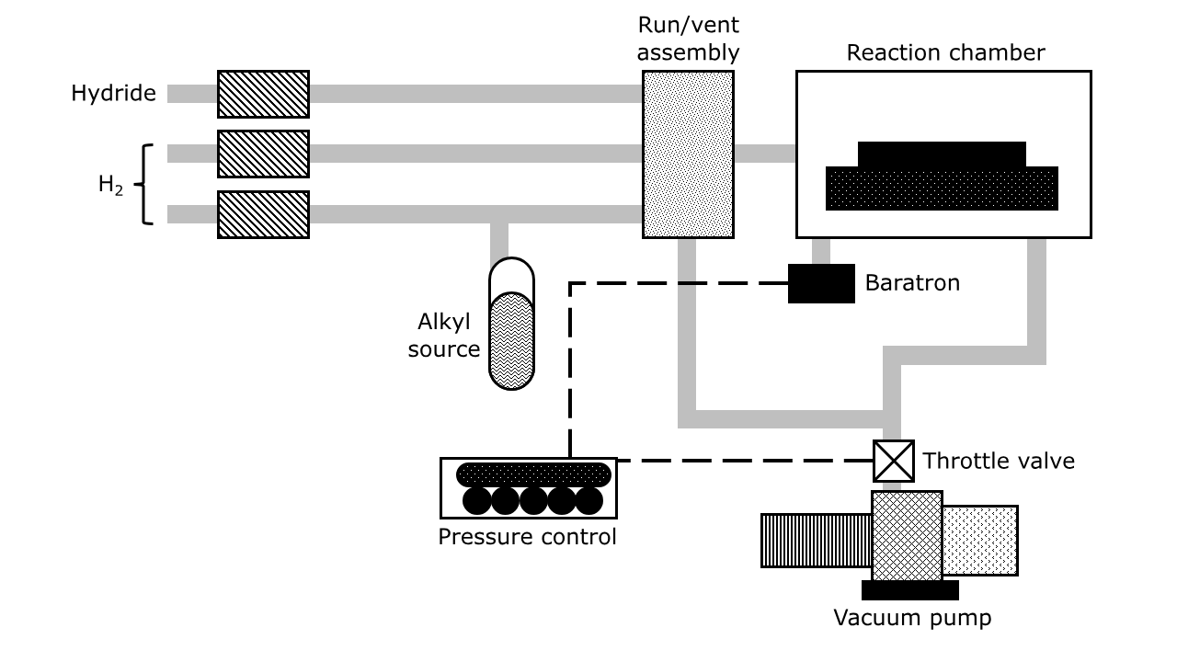
* Reaction: Pyrolysis of metalorganics to form InN and GaN thin films
* Example Reactions:
* (CH₃)₃In + NH₃ → 3CH₄ (gas) + InN (solid)
* (C₂H₅)₃Ga + NH₃ → 3C₂H₆ (gas) + GaN (solid)
* Exhaust System
* Rotary and diffusion pumps
* Removes gaseous by products safely
* Material Requirements
* Sufficient volatility
* Stable at room temperature
* Good partial pressure
* Forms desired element + easily removable by-products